|  |  |  |  |  |
| --- | --- | --- | --- | --- |
| Total no. of pages: | | | | |
| SG5015 Enterprise Architecture Assignment  SGLines  Enterprise Architecture Blueprint | | | | |
| Document Label: N.A | | | | | |
| Version: 1.0 | | | | | |
|  |  |  |  |  | |
|  | Name | Matriculation Number / Designation | Date | Signature | |
| Prepared By: | Han Jian Da | A0026472J | 10/05/2014 |  | |
|  | Chen Changfeng | A0006573J |  |  | |
|  | Robin Foe | A0092657U |  |  | |
|  | Kenny Hartono | A0092674W |  |  | |
|  | Gu Hongxiang | A0093803E |  |  | |
|  | Wu Jing | A0092670A |  |  | |
|  | Libra Pang | A0092698J |  |  | |
|  | Natanasihamani Saravanan | A0092609Y |  |  | |
| Reviewed By: |  |  |  |  | |

TABLE OF CONTENTS

Preliminary 5

Requirement Management 5

Statement Analysis 5

Assumption 12

Initiating EA Program – Architecture Vision 13

Problem Description 13

Stakeholders and their concerns 13

List of Issues/Scenarios to be Addressed 13

Vision Statement 13

Value Proposition 14

Scope 14

General Principles 14

Organisation Structure 15

Environment and Process Models 17

Actors, Roles and Responsibilities 19

Human Actors and Roles 19

Computer Actors and Roles 19

Business Architecture 21

Business Systems Model 21

Key factors 21

SWOT Analysis 22

Current SWOT Analysis 22

Target SWOT Analysis 23

Strategy Map 24

Business Reference Model 27

Performance Reference Model 27

Operating Model 28

Business Principles 29

Core Business Process for Current and Target States 30

Current Business Service 30

Current Business Process 31

Target Business Service 32

Target Business Process 33

List of Gap 34

Information Architecture 36

Data Principles 36

Date Entities Catalog 37

Target Conceptual Data Model 39

Target Data Entity/Business Function Matrix 40

Target Application/Data Matrix 40

List of Stakeholders and Concerns 42

Current and Target Information Architecture 43

Current Information Architecture 43

Target Information Architecture 44

Data Gaps and Recommendation 44

Application Architecture 46

Application Principles 46

Application Portfolio Catalog for Current and Target States 47

Current State 47

Target State 49

Target System/Business Function Matrix and System/Data Matrix 51

List of Stakeholders and their Concerns 53

Current and Target Application Architecture 54

Current application architecture 54

Target application architecture 55

List of Application Gaps and Recommendations 56

Technology Architecture 57

Technical Reference Model 57

Technical Principles and Best Practices 59

Current List of Technology Architecture 60

Target List of Technology Architecture 61

List of Stakeholders and their Concerns 62

Current and Target Technology Architecture 62

List of Technology Architecture Gaps 64

Opportunities and Solutions 65

Initiatives Description, Traceability, Priority 65

Checklist of Gaps and Addressed Gaps 66

Migration and Implementation Road Map 70

Project Identification, Quantification and Differentiation 70

# Preliminary

## Requirement Management

### Statement Analysis

The requirements goals for SG lines are broad and lack of information. The EA program is kick started with initial requirements gathering and fact analysis done by the team member.

|  |  |  |  |  |  |  |
| --- | --- | --- | --- | --- | --- | --- |
| ID | Reference | Statement | Concern | EA Domain | State | Action |
| SA 1 | S1, P1 | SGLines work with international partners to cover route segments in countries where SGLines do not Operate |  | BA | Baseline | FYI |
| SA 2 | S1, P2 | Shipping vessel and containers are manage globally through 2 different systems, VMS and CMS | lack of information flow | AA | Baseline | REQ |
| SA 3 | S1, P3 | Usage of Prediction Engine in CMS and ability to manual override the rules | | AA | Baseline | FYI |
| SA 4 | S1, P3 | CMS is used to track bulk sales of empty containers at ports that primarily used for import so as to minimise the number of empties being shipped |  | BA,AA | Baseline | FYI |
| SA 5 | S1, P3 | CMS also manage the transfer of containers from SGLines' vessels to vessels belonging to third party companies and track these containers while transported by third parties | | BA,AA | Baseline | FYI |
| SA 6 | S1, P4 | Different regional HQ , serve as main transhipment ports |  | BA | Baseline | FYI |
| SA 7 | S1, P5 | Separation of task of shipping vessels between regional and international routes |  | BA | Baseline | FYI |
| SA 8 | S1, P5 | Vessel on regional routes usually complete round trip within1 or 2 days, while international will take around 5 to 10 days |  | BA | Baseline | FYI |
| SA 9 | S1, P5 | Container may be transferred across multiple transhipment ports | Lost/miss placed of shipping item | BA | Baseline | FYI |
| SA 10 | S1, P6 | Expected decline of 40% of revenue due to the global economic recession and lost business to competitors due to price competition |  | BA | Baseline | Problem |
| SA 11 | S2, P1 | SGLines work with local operators of tow-heads to transport containers and empties to the designated location |  | BA | Baseline | FYI |
| SA 12 | S2, P1 | Little corporate guidance on how to engage local tow-head operators and local offices negotiate own deals. Little corporate knowledge of cost of engagement of local tow-head operators, except for summary cost item | non standardisation approach for procurement of services | BA | Baseline | Problem |
| SA 13 | S2, P2 | SGLines work with port operators in the countries it ships from where they are responsible for  optimizing loading, unloading and re-organization of containers pertaining to a shipping  vessel and cranes |  | BA | Baseline | FYI |
| SA 14 | S2, P2 | Each port operator run own optimization algorithm for loading, unloading and re-organisation of shipping vessels | Poor space utilisation, longer loading  and unloading times | BA | Baseline | Problem |
| SA 15 | S2.P2 | Most port operators prefer to work with shipping companies through cooperative computing | To optimize operations | BA | Target | REQ |
| SA 16 | S3, P1 | SGlines IT systems are primarily standalone | Lack of information sharing  between systems | AA | Baseline | Problem |
| SA 17 | S3, PT1 | Sales is done by customer through RFQ or order placement to SGLines sales team,  and quotation is sent by email, fax, or phone |  | BA | Baseline | FYI |
| SA 18 | S3, PT1 | Customer express the interest of ability to place order through internet, while larger customer  prefer a sort of better interaction between their in-house system with SGLines system |  | BA, AA, TA | Target | Problem |
| SA 19 | S3, PT1 | Loss of business when phone call were not answered because of staff absence | loss revenue | BA | Baseline | Problem |
| SA 20 | S3, PT1 | Viruses on the email attachment that crippled the office operations | Security issue | AA , TA | Baseline | Problem |
| SA 21 | S3, PT2 | Legacy SOS system is unsupported by vendor and do not have access to source code, thus unable to further enhance the functionality of SOS | Risk of breaking down and limitation to cater for business needs | BA , AA | Baseline | Problem |
| SA 22 | S3, PT2 | Sales summary is generated every month |  | BA, AA | Baseline | FYI |
| SA 23 | S3, PT2 | The need to access SOS system online |  | AA, TA | Target | REQ |
| SA 24 | S3, PT2 | Acceptance of quotation is done by EMAIL / Phone / Fax |  | BA | Baseline | Problem |
| SA 25 | S3, PT3 | Sales team call Order Processing Admin and passes the details of order or RFQ, and OPA will find out how fast the order can be fulfilled |  | BA | Baseline | FYI |
| SA 26 | S3, PT4 | Staff doubled as order processing administrator, in the event of unplanned absent, will cause significant delays for their customer and missed orders | Loss of revenue | BA | Baseline | Problem |
| SA 27 | S3, PT5 | Administrator will use VMS to check vessel availability and enquire vessel schedule |  | BA | Baseline | FYI |
| SA 28 | S3, PT5 | CMT will use CMS to verify vessel schedules and overall container movement chart |  | BA | Baseline | FYI |
| SA 29 | S3, PT5 | CMT will locate empties at the nearest regional ports and raise Container movement order to the pertinent local office, this will be done by fax, email , or phone |  | BA | Baseline | FYI |
| SA 30 | S3, PT6 | Transfer of empties is delayed, and cause missing scheduled departure, for some cases the delay have cost SGLines substantial amounts of money for recovery and damages | Penalties | BA | Baseline | Problem |
| SA 31 | S3, PT6 | Keeping track of container availability to meet demand is extremely critical | Reputation | BA, AA | Target | REQ |
| SA 32 | S3, PT7 | Long processes from OPA to ST and back to customer | Long process | BA | Baseline | Problem |
| SA 33 | S3, PT7 | Details of quotation are updated in the SOS |  | BA | Baseline | FYI |
| SA 34 | S3, PT8 | Customer need to accept quotation within 3 working days |  | BA | Baseline | FYI |
| SA 35 | S3, PT8 | When quotation is accepted, the ST update SOS and send a copy of order to the OPA by email | Email could get lost | BA | Baseline | Problem |
| SA 36 | S3, PT8 | Once quotation is accepted, the OPA request for customer to be billed through CBS |  | BA, AA | Baseline | FYI |
| SA 37 | S3, PT9 | VMS and CMS is developed in-house based on old technology, and often take too long to implement simple changes |  | AA | Baseline | Problem |
| SA 38 | S3, PT9 | VMS and CMS as high down time (around 10 - 15%) and this cause the whole operation comes to halt during the period | Lose of sales | AA, TA, DA | Baseline | Problem |
| SA 39 | S3, PT10 | SGLines has a website hosted by local ISP for marketing purpose, and about 2k hits per day |  | BA | Baseline | FYI |
| SA 40 | S3, PT10 | Customer would like to have additional capability to place order and check the calculation of shipment |  | BA, AA, TA, DA | Target | REQ |
| SA 41 | S3, PT10 | The website is not integrated with SGLines other IT system |  | AA, TA | Baseline | FYI |
| SA 42 | S3, PT11 | SGLines use AFIS and HRS for internal accounts and human resource management |  | BA. AA | Baseline | FYI |
| SA 43 | S3, PT11 | SGLines AFIS and HRS run on AS400 which has MQ Series |  | TA, AA | Baseline | FYI |
| SA 44 | S4, PT1 | To achieve greater internal business process efficiency |  | AV, BA | Target | REQ |
| SA 45 | S4, PT2 | To take full ads on the internet and broaden existing customer base |  | BA, AV | Target | REQ |
| SA 46 | S4, PT2 | To Provide customer with capability to register and directly place order online |  | BA, AV | Target | REQ |
| SA 47 | S4, PT3 | Improve customer service level by providing facilities such as online order submission, status checking, accelerated process for repeat orders and shipment status checking |  | BA, AV | Target | REQ |
| SA 48 | S4, PT4 | To use e-business to establish better network of local tow head operators and companies that supplies shipping containers more cheaply or more quickly |  | TA, IA, AV | Target | REQ |
| SA 49 | S5, PT1 | Consolidate SOS and CBS into 1 system called SCBS |  | AA | Target | REQ |
| SA 50 | S5, PT1 | App process and data management are to be hosted on the separated server, with redundancies to ensure maximum up time |  | TA | Target | REQ |
| SA 51 | S5, PT1 | Presentation layer for SCBS should be web based and all batch job shall be run at application tier |  | AA | Target | REQ |
| SA 52 | S5, PT2 | Consolidate VMS and CMS into 1 system called VCMS |  | AA | Target | REQ |
| SA 53 | S5, PT2 | App process and data management are to be hosted on the separated server, with redundancies to ensure maximum up time |  | TA | Target | REQ |
| SA 54 | S5, PT2 | To ensure system response time for is fast enough to cater prediction engines and other transactional process |  | IA , TA | Target | REQ |
| SA 55 | S5, PT3 | Integration between SCBS and VCMS for the submission and capture of RFQ, orders, and at the same time improving the overall processing efficiency and allow quicker business turnaround times. This will include automatic submission of CM orders to the local offices, and delivery estimation for ordered empties |  | BA, IA, TA | Target | REQ |
| SA 56 | S5, PT4 | All staff access will be standardized on IE web browser |  | AA | Target | REQ |
| SA 57 | S5, PT4 | Function required encryption for secure client side processing will be implemented using signed java applets |  | IA | Target | REQ |
| SA 58 | S5, PT5 | SCBS will be enhanced to allow customer submit order from new Web Storefront |  | BA, AA, TA | Target | REQ |
| SA 59 | S5, PT5 | Web content should be personalized for each customer type and country |  | BA, DA | Target | REQ |
| SA 60 | S5, PT5 | function required encryption for secure client side processing will be implemented using signed java applets |  | AA | Target | REQ |
| SA 61 | S5, PT6 | For more sophisticated customer, SCBS will provide a set of web service to allow customers' procurement systems to be integrated |  | IA, TA | Target | REQ |
| SA 62 | S5, PT7 | VCMS will also provide a set of web services for port operators to determine optimal container movement and placement within a vessel to support optimization for SGLines' vessels |  | IA , TA | Target | REQ |
| SA 63 | S5, PT7 | Future facilitation of EAI |  | IA, TA | Target | REQ |
| SA 64 | S5, PT8 | All transaction from staff and customer will be handled by the same set of application and database server |  | BA, AA | Target | REQ |
| SA 65 | S5, PT8 | However, for security purpose, separate Web Servers will be used to handle traffic from two different groups of users, reducing network latencies for the internal users |  | TA | Target | REQ |
| SA 66 | S5, PT9 | SCBS will access VCMS transactional data and produce management reports from consolidated data |  | IA, TA | Target | REQ |
| SA 67 | S5, PT9 | VCMS is mission critical, must not be impacted by the jobs that generate management reports |  | IA | Target | REQ |
| SA 68 | S6, PT1 | Although the business direction has been established at the exec level, there are some sections of the IT and Operations teams which are not supportive to this architecture redefinition, However , some champions are very closely aligned with the exec team priorities |  | Governance | Baseline | FYI |
| SA 69 | S6, PT2 | Staff who oppose the change include Solution Architects who support the legacy system, and see the new architecture as spelling their demise |  | Governance | Baseline | FYI |
| SA 70 | S6, PT3 | There are some broad cynics among the architects who do not believe in the principles of EA |  | Governance | Baseline | FYI |
| SA 71 | S6, PT4 | There are also those sceptics who see this as history repeating itself, in the sense that IT is investing in new system, technologies and infra as a way to justify their existence |  | Governance | Baseline | FYI |

### Assumption

After initial analysis of the statements above, the team come out with the below points are the assumption on SGLines current processes.

|  |  |  |
| --- | --- | --- |
| ID | Assumption | Remark |
| AS 1 | "SGLines consist of hierarchical structure of ORG chart  CEO" | Required by Architecture Vision |
| AS 2 | Each region HQ will have GM | Required by Architecture Vision and Governance |
| AS 3 | Each region will have different Org chart | Required by governance |
| AS 4 | Global ORG chart is different from Regional Org chart | Required by Architecture Vision |
| AS 5 | Profit centre and cost centre | Required by Business Architecture |



# Initiating EA Program – Architecture Vision

## Problem Description

### Stakeholders and their concerns

SGLines as a shipping company has huge diversity throughout the organisation that span across the globe. Their businesses run at the global scale that covers from States throughout the Asia regions. Although with huge coverage of businesses, SGLines doesn’t possess a good flow information from one department to another, not to mention a traditional way of process sales, which prone to human errors.

Further elaboration of the stakeholders and their concern is mapped through below table:

|  |  |
| --- | --- |
| Stakeholder | Key Concern |
| Customer | Ability to place order with higher turn around date |
| CxO | Losing sales? Prevent delay of shipment errors, Higher SLA, Cutting cost |
| Sales Team | Real time sales order generation, and faster feedback from RFQ, Improve Up time for VMS and CMS, at the same time improve customer service level through usage of technology |
| Order Processing Team | To have real time checking on vessel availability and container availability |
| IT and Operations | Sceptical on the investment of the new IT business goals, as they have no confident on the new system and technologies |
| Container Management Team | To have better recorded network with tow head operator, and hope could improve the efficiency of the local tow head operators. Current operation take too long to query a certain information from local tow head operator |

### List of Issues/Scenarios to be addressed

Through the initial study of SGLines business flow, the team manage to identify issues and scenarios to be addressed as per below:

* Reduce the operation cost of SGLines
* Losing of sales due to unanswered call from customer
* Consolidation of multiple systems based on the business domain to improve real time access
* Accurate Real time information throughout multiple departments
* Improve UP TIME for system that classified as critical
* Improve response time to customer

## Vision Statement

With the planned improvement by restructuring and reorganising the processes and work flow of the organisation, SGLines shall have significant improvement in terms of revenue and operating profit. Not to mention, with the help of modularity within department and better process work flow to achieve instant shared services / Information across multiple department within in bound and out bound of the organisation that will move to better customer care services .

The target architecture must be able to support and improve current SGLines business operation.

## Value Proposition

After years of operation, SGLines is in need to revamp the current flow of the processes that often considered as un-competitive to serve the day to day operation needs. After further analysis of current workflow of SGLines, it is obvious that the company suffer from losses from time to time due to human error and dependencies. There is a huge gap of communication within department that cause such issue and in turn drive them to lose of sales and revenue, not to mention mistakes done could lead to liquidated damages the company has to suffer. The value proposition for SGLines is “Increase Operational Profits and reduce sales losses”:

* **Increase Operation Profit,** SGLines predicted decline of sales up to 40% for years ahead due to global economic recession. Declining of sales must be compensated with better operation cost to minimises the losses and help the company to be more efficient in managing their internal workflow
* **Traceability of cost, network, and shipping movement** is another main event that SGLines must be able to trace the cost of engagement for each local tow head operators. At corporate level, this is an important factor, rather than depending on the bulk cost summary, an itemised billing based on the distance of travel would have better impact on setting up the routes they should take
* **Usage of ecommerce** portal as point of sales is another factor to retain the customer
* **Streamline the business processes** and automate certain task to speed up the fulfilment times
* **Create infrastructure environment** that enable service innovation by promoting flexibility in features implementation

## Scope

The scope of the architecture is enablement of enterprise wide architecture and governance through common principles of interoperability, migration and conformance. Motivation of the scope is derived from the lack of streamlined business processes and automation between departments as such each region has their own processes that do not adhere to the organisation standards.

The program aims to use the ADM phases that promote incremental development of the artefacts within the EA frameworks. The scope will focus on businesses and IT segments as per below:

* Define overall architecture description for regional level adherence
* Develop guidelines, rules and regulations that must be followed by other business segments
* Building architecture components based on the guidelines with certain flexibility in implementation and extension
* Define standard means of communication between different systems to assist better flow of information across the systems

## General Principles

The principles applied to EA wide implementation where:

* Business driver
  + No IT implementation should be made without business approved architecture
  + Processes must closely aligned with SG Lines missions
  + Requirements should closely aligned with the SG Lines vision
* Collaborative and Information flow
  + Every business unit of SGLines should show proactive response on the evolution of the proposed architecture
  + Architecture shall improve the information flow between business units to improve the processing and fulfilment times
* Leverage on existing infrastructure , implementation, and workflow where possible

## Organisation Structure

The diagram depicted from the preliminary phase, where SGLines has Global and Regional organisation structure.



### 



|  |  |  |
| --- | --- | --- |
| Entity | Roles & Responsibility | Report to |
| Global | | |
| Global CEO | Responsible for oversee overall company direction |  |
| Global HR | * Responsible for employee and head count management for global scale, at the same time approving hiring of new employee * Allocate staff transfer between regionals | Global CEO |
| Regional CEO | * Work with regional branch for business collaboration * Manage their own regional business direction | Global CEO |
| Global CIO | * Deciding guidelines and rules for company IT direction * Oversee IT implementation direction on global scale | Global CEO |
| HQ IT | * Define guidelines and manage approval of regional IT request | Global CIO |
| Global CFO | * Manage company Finance direction | Global CEO |
| Regional GM | * Define company business vision and work closely to ensure the vision is fulfilled | Global CFO , Global CEO |
| Regional | | |
| HR Manager | * Manage head counts internally | Regional CEO, Global HR |
| Operation Team | * Manage daily business operation * Look for new sales * Support customer queries * Perform checking on shipment and vessels | Regional CEO |
| Regional CIO | * Oversee regional IT alignment | Global CIO |
| IT Department | * Manage day to day IT task | Regional CIO |
| Regional CFO | * Oversee regional company finance direction | Global CFO |
| Finance Manager | * Ensure goals set by regional GM is achieved | Global CFO |

## Environment and Process Models

Further on the planning of SGLines EA blue print, the company direction is to scrutinise the cluttered process model where there are too many unnecessary steps that cause delay in timing, role duplication and inaccurate information. This has cause a lot of losses in term of monetary to SGLines, not to mention lead to poor customer satisfaction on the service provided by SGLines.

The Ideal processes flow for SGLines would be to minimise the effort of each staff , improve the response time and information readiness thus will lead to better efficiency in resource utilisation (be it human or non-human resources). The new process flow will consist of :

* **Global Sales** , where it handle all the sales from internal staff or external customer
* **Space Tracing** ¸ for vessel and container availability with the predefined routes and calculation of the most effective cost
* **Global Payment**, that handles the payment from customer and billing from third party vendors. The process will handle in multiple currency
* **Shipment Tracking** to ensure the success and prevent losses of every delivery, every customer item will be tagged with specialised identification, where it can be used to track the location of the item, which container and scheduled departure from and arrival to date



Figure Value Chain Diagram

Most of the business process in SGLines needs to have accompanying technology and business environment to support the activity.

|  |  |  |  |
| --- | --- | --- | --- |
| **Business Process** | **Environment** | | **User Group** |
| **Business** | **Technology** |
| **Global Sales** | * Customer * Client * Sales Personnel * Competitor | * Sales ordering system * Sales portal | * Sales Process Team * Order Process team |
| **Space Tracing** | * Customer * Client * Local tow head * Country rules and regulation | * Vessel and Container management * Prediction engine | * Container management Team |
| **Global Payment** | * Customer * Client * Bank Merchant * Rules and regulation * Currency Exchange rate | * Global payment portal * Account management | * Bank Merchant * Order Processing Team |
| **Shipment Tracking** | * Port Rules and regulation * Customer / client * Local tow head operator | * ShipTrack system | * Container management Team |
| **Reporting** | * All other business processes | * Reporting Tools | * Senior / top level management |

**Information Flow**

With the above explanation, SG lines is divided into 5 different processes, each process will trigger the next processes sequentially through the successive chain of information transfer from 1 process to another.

The steady flow of information is critical and need to be identified early to ensure there are no hiccup along the while process flow. Below is the further explanation of the steady flow of information in detail:

* **The initial** **state** is the information from customer or client that requested to ship and item based on the weight, size, and custom declaration of the items. Every information will go through Global Sales process before it is escalated further for **space tracing**
* **Space tracing** is when user have submitted required information and need to have arrangement on the vessel and shipping confirmation. This process should took less than a day
* Once everything is completed and user is agree with the routes, they will proceed with the payment through the Sales order generated by Global Sales process. The order will indicate the detail of the items and the total purchase prices in multiple currency
* Last Flow of the information would be the tracking of the shipment. Through payment SGLines will trigger tow head operator on the incoming request. The request will be handled by the tow head operator and processed accordingly. The information on current status of the item will be updated regularly by tow head operators

## Actors, Roles and Responsibilities

### Human Actors and Roles

|  |  |
| --- | --- |
| Actor | Role |
| Sales Team | * Process the incoming sales * Help with order realisation between customer and SGLines |
| Order Process team | * Carry forward the task of sales team * Generate purchase order and bill the customer |
| Container Management Team | * Maintain close relation with local horizon office * Manage Vessel and container scheduler and space |
| Web User | * Ad hoc User that purchase shipping service |
| CxO | * Manage overall SGLines direction |
| IT Support | * Provide 8/5 IT support to the system * Maintain report batch timing to be generated by the system |
| Local tow head operators | * Transport loaded containers and empties to the locations where they needed |
| Dock Operators | * Optimizing and loading, unloading, reorganization of containers |
| Partner | * Company partners in a business or firm with shared risks and profits |
| Customer | * Experience services from SGLines |

### Computer Actors and Roles

|  |  |
| --- | --- |
| Actor | Role |
| SCBS | * Manage Vessel schedule * Manage Container Schedule * Advance analytics and prediction engine * Maintain local tow head operators with the cost * Process sales * Process payment * Process PO generation |
| VCMS | * Track client shipment process |
| Shipment Tracking | * Serve as static FAQ of the company * Allow purchasing of SGLines service * Allow preview of shipment tracking |
| SGLines Website | * Act as separate entity that publish web service Interfaces to other company |
| Interface Engine | * Act as SGLines internal account and financial system |
| AFIS | * Act as internal Human Resource System |
| HRS | * Business intelligent reporting tools that extract data form Data Warehouse |
| Report | * Store and process the data from different system. Act as Single source of truth among system communication * Only track pertaining report and Interface Engine |

# Business Architecture

## Business Systems Model

### Key factors

1. To achieve greater internal business process efficiency, through process integration and better use of its IT systems:

* Consolidation of system:
  + Sales Order System (SOS) and Customer Billing System (CBS) will be combined as Sales and Customer Billing System (SCBS)
  + Vessel Movement System(VMS) and Container Movement System(CMS) will be combined as Vessel and Container Movement System (VCMS)
* Integration between Vessel and Container Movement System (VCMS) and Sales and Customer Billing System (SCBS) to improve overall order efficiency
* Sales and Customer Billing System (SCBS) allow web store front order
* Service Oriented Architecture for Vessel and Container Movement System (VCMS) and Sales and Customer Billing System (SCBS) to allow third party Web Service call

1. To take full advantage of the Internet and broaden the existing customer base:

* Online Order Submission & Order Status Checking
  + Accepting orders when and where the customer wants to place them
  + Making it easy to check the order status
* Sales and Customer Billing System (SCBS) will provide a set of Web Services to allow customers’ procurement systems to be integrated

1. To improve the overall customer experience and customer service:

* Online Order Submission & Order Status Checking
  + Accepting orders when and where the customer wants to place them
  + Making it easy to check the order status

1. To use e-business to establish a more effective manner for the business processes to integrate with company’s suppliers’ IT systems:

* Vessel and Container Movement System (VCMS) will provide a set of Web Services for Port Operators to determine optimal container movement and placement within a vessel to support optimization decisions for SGLines’ vessels

## SWOT Analysis

### Current SWOT Analysis

The below table shows SGLines’ current business architecture strengths, weaknesses, opportunities and threats.

|  |  |
| --- | --- |
| **Strengths** | **Weaknesses** |
| * Worldwide Shipping * Vast knowledge on shipping network and local destination * “Reachability” event at the most remote geographical area * “Human Touch”, deal directly with operators for order placement | * Un-clear job description * Un-automated processes * Sales order placement only available during working hour or staff availability * Error prone and high processing time * Missing clear view of local tow head operators from upper management level(lack of visibility or transparency) * Non standardization on space utilization * Business dependant on un-robust system * Delayed or miss shipment schedule |
| **Opportunities** | **Threats** |
| * Automated processes to reduce manual intervention * Allow order placement 24/7/365 * Shorten the business processes (Activity) to increase efficiency * Paperless integration * Integration with port operators for optimization operation | * Resistance from key user * Time taken to re-train the staff * Losses of revenue due to the un-entertained customer * Forecasted slower revenue due to global economic recession * Penalties on delayed shipment * System down time often halts the business operation |

### Target SWOT Analysis

The below table shows SGLines’ target business architecture strengths, weaknesses, opportunities and threats.

|  |  |
| --- | --- |
| **Strengths** | **Weaknesses** |
| * Worldwide Shipping * Vast knowledge on shipping network and local destination * “Reachability” event at the most remote geographical area * “Human Touch”, deal directly with operators for order placement * Lower operating cost * Fast Turnaround time * Good customer service * 24/7/365 Order placement * Information Readiness throughout whole organisation * Information transparency and visibility | * On the fly report readiness * Customer experience on online order placement * High Transformation cost * Concerns on internet security * Precise tracking on the shipping item |
| **Opportunities** | **Threats** |
| * Integration with business intelligent reports * Secured channel for payment integration * Boarder payment gateway | * Staff knowledge to interpret analytical reports * Leak of customer sensitive information |

We can address “Some staff (e.g. IT and Operations team) not willing to change to the new architecture redefinition” weakness:

* Management team should have briefing to all staff for the purpose and benefits of new architecture
* Learning and Organization team should organize learning and communication session with all staff
* Establish formal feedback exercise for employees to raise voice concerns

To address “Mission critical systems” threat:

* Proper control and procedure in application team, infrastructure team and system operations team
* Establish formal policies and procedures for mitigating risk such as resource turnover.
* Establish internal reporting/approval process, e.g.:
  + System migration and deployment
  + Change management
  + Incident resolution
* Plan and schedule disaster recovery exercise
* Establish detailed Service Level Agreements (SLA) for all running applications
* To conduct regular training exercise for all IT and Operations team

To address “New process and applications” threat:

* Proper User Acceptance Testing (UAT) must be done before applications release, staff will have fewer difficulties to use and understand the system
* To conduct thorough orientation and training program for all staff to be familiar with the new process and applications
* To gather feedback from staff on how to optimize the process and applications
* Continuously internal support from management team
* Continuously internal support from IT and Operations team
* Provide "Hands On" Training and educate the staff for establishing the new system

## Strategy Map

The Strategy Map describes how SGLines can achieve its vision, mission and customer value proposition. The Ace Manufacturing Strategy is decomposed into four important perspectives to create sustained long term shareholder value:

* Learning and Growth
* Internal Process
* Customer
* Financial

The graphical representation of Strategy Map for SGLines is shown below:

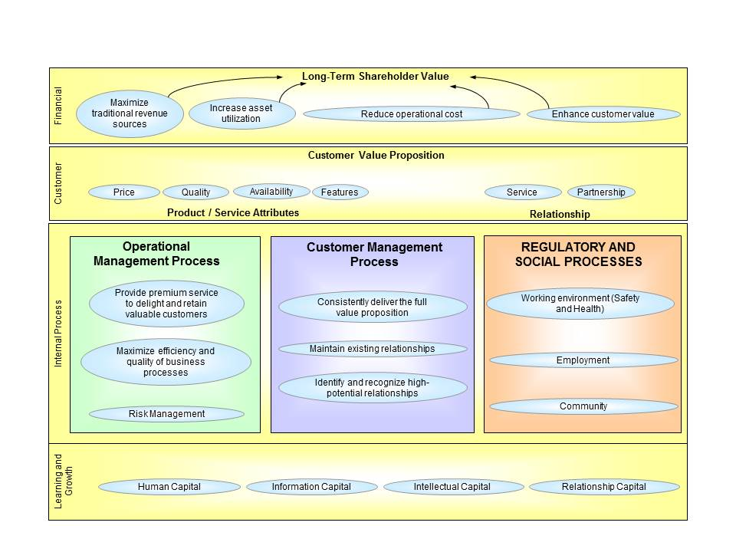

Figure Strategy Map

With the main vision of improvement in operational profit and enhance customer experience, SGLines business strategies shall fall within the below categories:

* **Financial** 
  + **Improve Cost Structure** through elimination of unnecessary processes and transparency of company expenditure
  + **Increase Asset Utilisation** through the mean of order automation and estimates delivery for empty vessels, which can improve overall order process efficiency
  + **Enhance Customer value** by providing accurate and timely information such as tracking and tracing of orders, fast and accurate quotation generation, shorten waiting time for queries
* **Customer** 
  + **Availability** **and Service** in sales order processing, query by customer, through the mean of self-service or with the help of hot lines.
  + **Strategic Partnership**  with existing partner to build a stronger relationship at the same time to establish effective communication that promote transparency and traceability
* **Internal Process**
  + **Operational Management Process**
    - Provide premium service to delight and retain valuable customers
    - Maximize efficiency and quality of business processes
    - Mitigate the risk that could arise from integrating different systems
    - Regularly assess the effectiveness of SGLines’ business processes for continual improvement
  + **Customer Management Processes**
    - Consistently deliver the full value proposition
    - Maintain existing relationships
    - Identify and recognize high-potential relationships in different regions
* **Learning and Growth**
  + **Human Capital**
    - Conduct internal training session to understand the new EA for all staff
    - Consult with external EA expertise during the transition exercise
    - Conduct training session for IT and Operations team to follow the new process and operation procedure
  + **Information Capital,** It includes various systems, databases and networks.
  + **Intellectual Capital,** Collective knowledge (whether or not documented) of the individuals in the company. This knowledge can be used to produce wealth, multiply output of physical assets, gain competitive advantage, and to enhance value
  + **Relationship Capital,** Improve relationship with existing customers and partners to build a relationship

## Business Reference Model

The Business Reference Model describes the functions provided by SGLines to its customers and partners. SGLines’ BRM is structured into a hierarchy of business functions with services (vertical) offered to the external customers and partners, services (horizontal) offered to the staffs and the internal services required to support the organizations operations.

The figure below provides the overview of SGLines’ BRM:

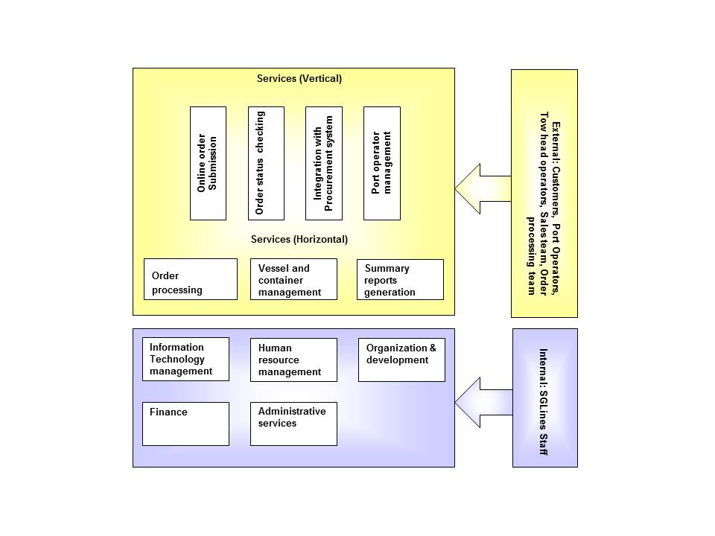

Figure Business Reference Model

## Performance Reference Model

The PRM was designed to serve three main purposes:

* Help produce enhanced IT performance information to improve strategic and daily decision making
* Improve the alignment, and better articulate the contribution of IT to business outputs and outcomes
* Identify performance improvement opportunities that span traditional organizational structures and boundaries.

As shown in below, the PRM includes four Measurement Areas: Mission and Business Results, Customer Results, Processes and Activities, Human Capital, Other Fixed Assets and Technology. In each area, there are Measurement Categories.

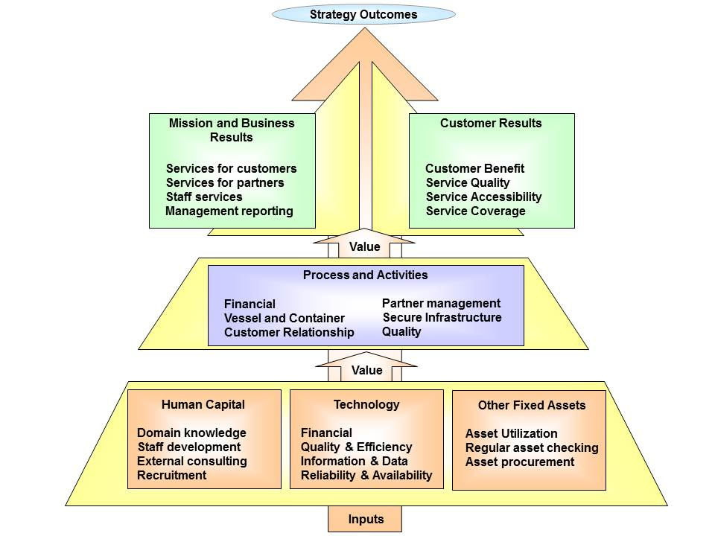

Figure Performance Reference Model

## Operating Model

Operating Model represents the required level of process integration and standardization to deliver services to the customers, focusing on core business process. It enables the implementation of strategic initiatives.

"The Coordination model provides integrated service to each key customer group. The integration results from sharing key data across the business units to present a common fact to the customer." (Enterprise Architecture As Strategy, by Ross, Weill, and Robertson). The operational model of the SGLines is Coordination operational model based on CISR. It’s because of the following reasons:

* Shared customers worldwide
* All data are shared across different systems and units
* Operationally similar business units, however regulations and rules may change from region.
* Each department manages their own IT systems which are not integrated with each other and not integrate with HQ
* Web site is not integrated with SGLines’ other IT systems although it gets 2000 hits per days
* Long time to implement even simple changes due to lack of internal resources
* Even Business-critical systems in individual factories have unscheduled downtime of average 10% to 15%
* Existing systems do not scale according to the business growth
* Main target is to provide efficient and quality process with competitive price

## Business Principles

|  |  |
| --- | --- |
| **Name** | **Enhance customer value** |
| **Statement** | Enhance existing customer satisfaction and expand potential customers |
| **Rationale** | The customer’s total experience directly affects perceptions of value. By providing more efficient services (e.g. online ordering and status checking) which can sustain existing customer’s relationship and expand potential customers |
| **Implications** | Application should be more efficiency and easy to use (e.g. clear user interface) |

|  |  |
| --- | --- |
| **Name** | **Business Integration** |
| **Statement** | Architectures target to streamline interoperability between business functions |
| **Rationale** | Business processes are best improved by streamlining the flow and use of data and information |
| **Implications** | Share information (e.g. Data) between different business unit |

|  |  |
| --- | --- |
| **Name** | **Business Continuity** |
| **Statement** | Mission critical IT systems should ensure maximum uptime and reduce business inability |
| **Rationale** | We must consider the reliability of mission critical systems throughout their design and use. The integrated applications are made available to customers and staffs 24x7 to ensure there is no service disruption for ordering, processing and billing processes |
| **Implications** | * Proper control and procedure in application team, infrastructure team and system operations team * Establish formal policies and procedures for mitigating risk such as resource turnover * Establish internal reporting/approval process, e.g.:   + System migration and deployment   + Change management   + Incident resolution * Plan and schedule disaster recovery exercise * Establish detailed Service Level Agreements (SLA) for all running applications * To conduct regular training exercise for all IT and Operations team |

|  |  |
| --- | --- |
| **Name** | **Improve partner relationships** |
| **Statement** | Enable multiple channels of access to the company by implementing Web Services to integrate partners’ IT systems with the company |
| **Rationale** | Business partner is key value co-creator with the company. It is necessary to communicate with partner’s IT systems in order to automate and optimize the company’s own business processes |
| **Implications** | Implement service oriented approach which will enable integration of company’s IT systems with partners’ IT system |

## Core Business Process for Current and Target States

### Current Business Service

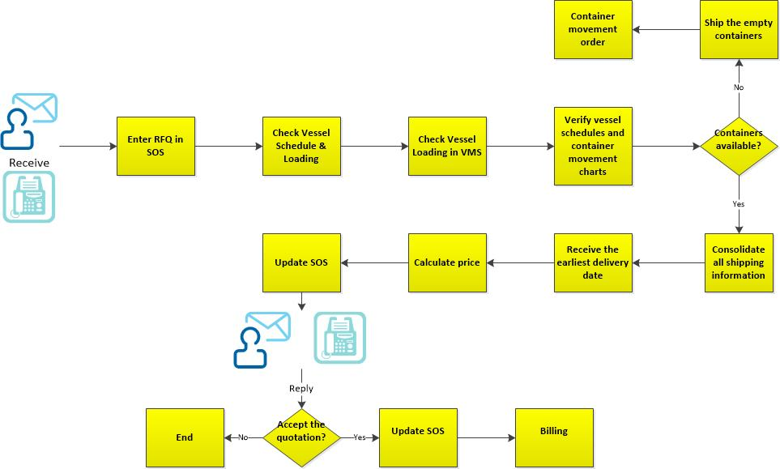

### Current Business Process

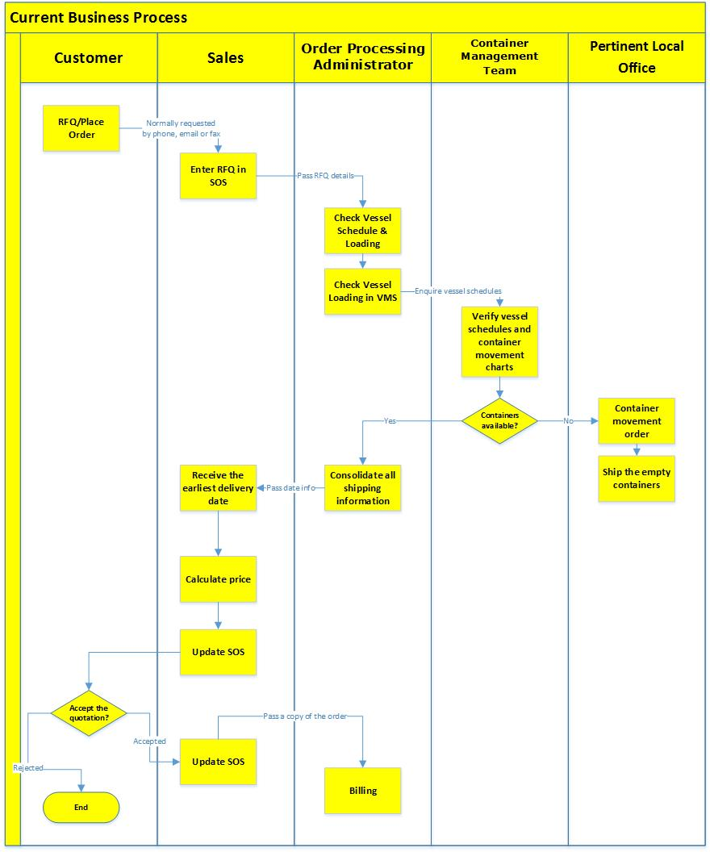

### Target Business Service

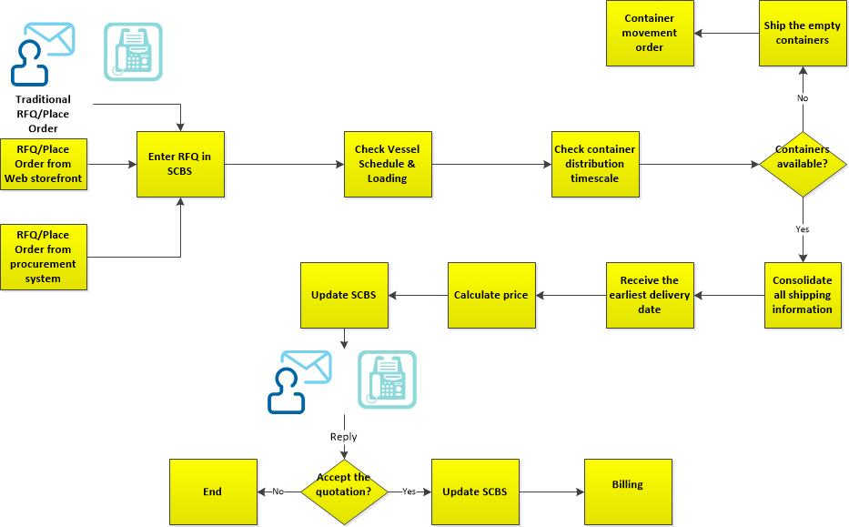

### Target Business Process

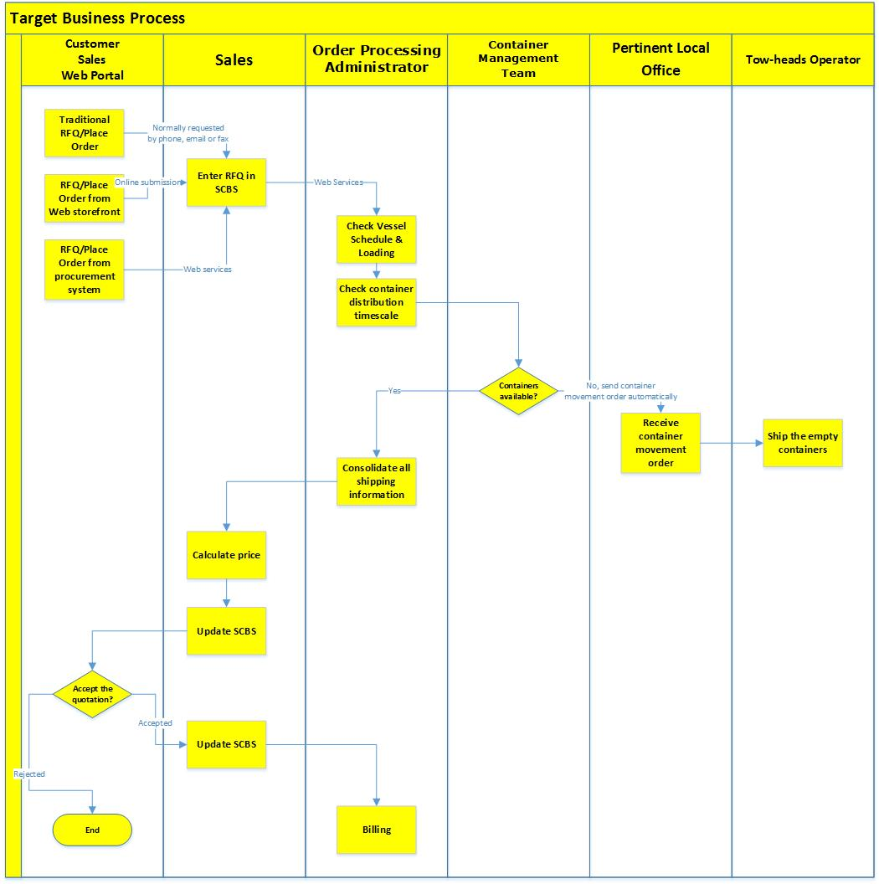

## 

## List of Gap

|  |  |  |  |  |  |
| --- | --- | --- | --- | --- | --- |
| Gap | Description | Current State | Future State | Importance/Benefit | Address by Architecture |
| Gap 1 | Online order submission and tracking | Customer RFQ through email, fax and phone | Customer RFQ or order is placed through web storefront | Main business entry point  Customer satisfaction and process efficiency | Information/Application |
| Gap 2 | Integrated e-Business with partner and customer’s IT system | Customer RFQ through email, fax and phone | Automated order process with customer 's procurement system | Enhance partner and customer relationship | Information/Application |
| Different port operators to run their own optimization algorithm which resulted in poor space utilization | Web services provided by VCMS to optimize container movement and placement |
| Gap 3 | Sales and Customer Billing System | Separate Sales Order system and Customer Billing System | Integrated Sales and Customer Billing System (SCBS) | Accurate reporting to management  Reduce human errors in the original process  Streamline the business process to improve service quality | Information/Application |
| RFQ/Order manually processed | Online order submission and tracking |
| Order pricing manually calculated | Integrated Sales and Customer Billing System (SCBS) |
| Customer billing is manually prepared and triggered by order processing administrator | Customer billing is automatically prepared and sent by SCBS |
| Quotation or order status are manually changed by sales team | Quotation or order status are automatically updated by SCBS |
| Gap 4 | Vessel Movement System and Container Movement System | These 2 systems in individual factories have unscheduled downtime of average 10% to 15%. | Centralized Vessel and Container Movement System (VCMS) should have high levels of redundancies to ensure 24 x 7 operations | Ensure high availability for mission critical system to reduce business lost | Information/Application |
| Gap 5 | Centralized report generation and data management | Inaccurate sales report and transaction data due to human activities | SCBS will access VCMS’s transaction data and produce management reports | Reports are a very useful method for keeping track of important information. The information contained in reports can be used to make very important decisions that affect our lives daily. | Information/Application |

# Information Architecture

## Data Principles

|  |  |
| --- | --- |
| **Name** | **Data Integration** |
| **Statement** | Data is defined consistently throughout the company, and the definitions are understandable and available to all users |
| **Rationale** | With integration between applications, it will allow quicker business turnaround times. |
| **Implications** | Multiple data standardization initiatives need to be co-ordinated. |

|  |  |
| --- | --- |
| **Name** | **Data Replication** |
| **Statement** | Data to be replicate and assessable without interrupting online transaction |
| **Rationale** | For efficiency and effectiveness in decision-making and service delivery. |
| **Implications** | Data is should be sufficiently, able to meet a wide range of requirement. |

|  |  |
| --- | --- |
| **Name** | **Data is an Asset** |
| **Statement** | Data is an asset that has value to the company and is managed accordingly |
| **Rationale** | The purpose of data is to aid decision-making. |
| **Implications** | Stewards must have the authority and means to manage the data for which they are accountable |

## Date Entities Catalog

|  |  |  |  |  |  |  |  |  |  |  |
| --- | --- | --- | --- | --- | --- | --- | --- | --- | --- | --- |
| ID | Name | Description | Date | Category | Priority | Source | Data Category | Privacy Classification | Retention Classification | Owner |
| ISA_DE_01 | Location | The location of the vessel, container and movement routes | 2014 | Data Architecture | Medium | Container Management Team | Data Architecture | Medium | Medium | IT |
| ISA_DE_02 | Container | The container information | 2014 | Data Architecture | High | Container Management Team | Data Architecture | Medium | Medium | IT |
| ISA_DE_03 | Movement | The movement tracks for specific containers | 2014 | Data Architecture | Medium | Container Management Team | Data Architecture | Medium | Medium | IT |
| ISA_DE_04 | Vessel | The vessel information | 2014 | Data Architecture | High | Container Management Team | Data Architecture | Medium | Medium | IT |
| ISA_DE_05 | Customer | Customer’s profiles | 2014 | Data Architecture | High | Sales Team  and  Order Processing Administrator | Data Architecture | High | High | IT |
| ISA_DE_06 | Billing | The billing info for specific orders | 2014 | Data Architecture | High | Sales Team  and  Order Processing Administrator | Data Architecture | High | High | IT |
| ISA_DE_07 | SalesOrder | The order information | 2014 | Data Architecture | High | Sales Team  and  Order Processing Administrator | Data Architecture | High | High | IT |
| ISA_DE_08 | Agent | Agent information | 2014 | Data Architecture | Low | Container Management Team | Data Architecture | Low | Low | IT |

## Target Conceptual Data Model

The following target conceptual model gives the associated stakeholders a higher level understanding of the business entities as well as a tool by which they can view how their business relation information



## Target Data Entity/Business Function Matrix

|  |  |  |  |  |  |  |  |  |  |  |
| --- | --- | --- | --- | --- | --- | --- | --- | --- | --- | --- |
| Data Entities \ Business Function | Vessel Loading/Schedules Maintenance | Container Movement Timescales Maintenance | Sales Order Maintenance | Billing Maintenance | Distribute empty shipping containers by Prediction Engine or Manual Intervention | Track sales of empty containers | Track transfer of containers from SG’s vessels to 3rd party vessels | Payment | Reporting Function | Shipment Tracking Maintenance |
| Sales Order | R | R | CRUD | RU |  |  |  |  | R | RU |
| Vessel | R |  | CRUD |  |  |  |  |  | R | RU |
| Container | R | R | CRUD |  | CRU | CRU | CRU |  | R | CRU |
| Billing |  |  | C |  |  |  |  | CRUD | R |  |
| Agent |  |  | C |  |  |  |  |  | R |  |

## Target Application/Data Matrix

|  |  |  |  |  |
| --- | --- | --- | --- | --- |
| Data Entities \ Application | Vessel and Container Movement System (VCMS) | Sales and Customer Billing System (SCBS) | Integrated Reporting System (IRS) | Ship Track System (ST) |
| Sales Order | R | R | R | R |
| Vessel | CRUD |  | R |  |
| Container | R |  | R |  |
| Billing |  | CRUD | R |  |

## List of Stakeholders and Concerns

|  |  |  |  |
| --- | --- | --- | --- |
| No. | Stakeholder | Concerns | View |
| 1. | Customer | Order and billing details are captured, updated and deleted accurately.  Data is secured with high availability. | Conceptual data model, Data entity/ Business Function Matrix |
| 2. | Executive/Management team | Details are captured for business analysis and decision making.  Details are captured accurately. | Data entity / business function matrix |
| 3. | IT staffs | Data is secured with high availability.  Data is controlled based on access rights.  Data is accessible/update from web interface/web services. | Conceptual data model, Data entity / business function matrix |
| 4. | Salesmen | Order and billing details are captured, updated and deleted accurately.  Data is secured with high availability. | Conceptual data model, Data entity / business function matrix |
| 5. | Container management team | Vessel details, container details are captured, updated and removed accurately.  Data is secured with high availability. | Conceptual data model, Data entity / business function matrix |
| 6. | Tow-head operator | Data passing to VCMS is captured, updated and removed accurately.  Data is secured with high availability. | Data entity / business function matrix |
| 7. | Port operator | Data passing to VCMS is captured, updated and removed accurately.  Data is secured with high availability. | Data entity / business function matrix |
| 8. | Order Processing Administrator | Vessel details, container details are captured, updated and removed accurately.  Data is secured with high availability. | Conceptual data model, Data entity / business function matrix |

## Current and Target Information Architecture

### Current Information Architecture

Each individual system had their own data/information:



### Target Information Architecture



## Data Gaps and Recommendation

|  |  |  |  |
| --- | --- | --- | --- |
| No. | Data Gaps | Recommendation | Potential Benefits |
| 1. | Different data format between Company with Port Operators | Work together to follow or create a standard that be used by both parties | Unique data formatting standard for maintenance |
| 2. | Duplicate Customer, Agent entity in Sales Order and Billing System | To be merged | Reduce data redundancy |
| 3. | Duplicate Location entity in Vessel and Container Maintenance System | To be merged | Reduce data redundancy |

|  |  |  |  |  |  |  |  |
| --- | --- | --- | --- | --- | --- | --- | --- |
| Target  Baseline | Vessel | Container | Movement | SalesOrder | Agent | Customer | Billing |
| Vessel | Included |  |  |  |  |  |  |
| VesselLocation |  |  |  |  |  |  |  |
| Container |  | Included |  |  |  |  |  |
| ContainerLocation |  |  |  |  |  |  |  |
| SalesOrder |  |  |  | Included |  |  |  |
| SalesOrderAgent |  |  |  |  | Potential match |  |  |
| SalesOrderCustomer |  |  |  |  |  | Potential match |  |
| Billing |  |  |  |  |  |  | Included |
| BillingAgent |  |  |  |  | Potential match |  |  |
| BillingCustomer |  |  |  |  |  | Potential match |  |
| NEW |  |  | Gap: To be developed or produced |  |  |  |  |

# Application Architecture

## Application Principles

|  |  |
| --- | --- |
| **Business Principle** | **Enhance customer value** |
| **Name** | **Ease-of-use** |
| **Statement** | Applications are easy to use. The underlying technology is transparent to users, so they can concentrate on tasks at hand. |
| **Rationale** | The more a user has to understand the underlying technology, the less productive that user is. Ease-of-use is a positive incentive for use of applications. It encourages users to work within the integrated information environment instead of developing isolated systems to accomplish the task outside of the enterprise's integrated information environment. Most of the knowledge required to operate one system will be similar to others. Training is kept to a minimum, and the risk of using a system improperly is low. |
| **Implications** | Applications will be required to have a common "look-and-feel" and support ergonomic requirements. Hence, the common look-and-feel standard must be designed and usability test criteria must be developed.  Guidelines for user interfaces should not be constrained by narrow assumptions about user location, language, systems training, or physical capability. Factors such as linguistics, customer physical infirmities (visual acuity, ability to use keyboard/mouse), and proficiency in the use of technology have broad ramifications in determining the ease-of-use of an application. |

|  |  |
| --- | --- |
| **Business Principle** | **Business Integration, Improve partner relationships** |
| **Name** | **Data Interchange Capabilities** |
| **Statement** | Applications are able send and receive data to/from other application in the enterprise. |
| **Rationale** | Data are generated within the application. The data may be used by other application to automate the business process. The capabilities to interchange data between applications are a high priority task. |
| **Implications** | Failure to interchange data between applications will fail the whole applications integration process. |

## 

## Application Portfolio Catalog for Current and Target States

### Current State

|  |  |  |  |  |  |  |  |  |
| --- | --- | --- | --- | --- | --- | --- | --- | --- |
| **No.** | **Application Name** | **Description** | **Business Owner** | **Maintainer** | **Hardware/Software Platform** | **Status** | **Related Applications** | **Remarks** |
| 1. | Vessel Movement System (VMS) | Provides data about vessel information and availability. | Order Processing Administrator | In-house | High-end WinTel servers / Old technology software | Operational | Container Movement System (CMS) | Long development time, lack of internal resources, 10% to 15% unscheduled downtime. |
| 2. | Container Movement System (CMS) | Provides vessel information, schedules, and container movement timescales. | Container Management Team | In-house | High-end WinTel servers / Old technology software | Operational | Vessel Movement System (VMS) | Long development time, lack of internal resources, 10% to 15% unscheduled downtime. |
| 3. | Sales Order System (SOS) | Provides quotation details, order details, and sales summary. | Sales Team | In-house | Running on a PC at each local office / Custom-built application, written in 1991 by an external software company that has since gone out of business. | Operational |  | More functions are required, but SOS source code is missing. Salesmen need mobile, online access. |
| 4. | Customer Billing System (CBS) | Allows Order Processing administrator to requests for the customer to be billed. | Order Processing Administrator | In-house |  | Operational |  |  |
| 5. | SGLine Website | Displays SGLines’ marketing literature. | Marketing Team | In-house | Servers at local ISP’s server | Operational |  | More features are required, e.g. RFQ, ordering, calculations of shipment time between destinations, etc. The website is not integrated with other SGLine’ other IT systems. |
| 6. | Account and Financial Information System (AFIS) | Keep track of account and financial information. | Finance and Account Team | In-house | AS400 servers | Operational |  | It has adapters for MQ series and a Java API which never been used before. |
| 7. | Human Resource System (HRS) | Keep track HR related data. | HR Team | In-house | AS400 servers | Operational |  | It has adapters for MQ series and a Java API which never been used before. |

### Target State

|  |  |  |  |  |  |  |  |  |
| --- | --- | --- | --- | --- | --- | --- | --- | --- |
| **No.** | **Application Name** | **Description** | **Business Owner** | **Maintainer** | **Hardware/Software Platform** | **Status** | **Related Applications** | **Remarks** |
| 1. | Vessel and Container Movement System (VCMS) | Order Processing Administrator to check for the availability of vessels.  Container Management Team to check for vessel schedules and the overall container movement timescales.  Port Operators to determine optimal container movement, placement within a vessel and support optimization decisions via VCMS’s web services. | Order Processing Administrator  and  Container Management Team | In-house | Internal Servers/Java, Oracle technology | Planned | Sales and Customer Billing System (SCBS) | Prediction engine from the previous application needs to be migrated to the new system.  Although prediction engine requires a high computational load, the system response time should not be adversely impacted when the prediction algorithm is running. |
| 2. | Sales and Customer Billing System (SCBS) | Provides quotation details, order details, and sales summary to Sales Team.  Allows Order Processing administrator to requests for the customer to be billed. | Sales Team  and  Order Processing Administrator | In-house | Internal Servers/Java, Oracle technology | Planned | Vessel and Container Movement System (VCMS) | Ensure 24x7 operations, high level redundancies.  Application processing and data management are to be hosted on separate servers. |
| 3. | Integrated Reporting System (IRS) | Provides reports by collecting data from various applications. | Management Team | In-house | Internal Servers/Java, Oracle technology | Planned | VCMS, SCBS, ShipTrack | Collecting data for report generation should not affect the other application operation. |
| 4. | ShipTrack System (ST) | Maintain shipment details, provides shipment information. | Container Management Team | In-house | Internal Servers/Java, Oracle technology | Planned |  |  |
| 5. | Account and Financial Information System (AFIS) | Keep track of account and financial information. | Finance and Account Team | In-house | AS400 servers | Operational | Sales and Customer Billing System (SCBS) | It has adapters for MQ series and a Java API which never been used before. |
| 6. | Human Resource System (HRS) | Keep track HR related data. | HR Team | In-house | AS400 servers | Operational |  | It has adapters for MQ series and a Java API which never been used before. |

## Target System/Business Function Matrix and System/Data Matrix

|  |  |  |  |  |  |  |  |  |  |  |  |  |  |
| --- | --- | --- | --- | --- | --- | --- | --- | --- | --- | --- | --- | --- | --- |
| System \ Business Function | Vessel Loading/Schedules Maintenance | Container Movement Timescales Maintenance | Sales Order Maintenance | Billing Maintenance | Distribute empty shipping containers by Prediction Engine or Manual Intervention | Track sales of empty containers | Track transfer of containers from SG’s vessels to 3rd party vessels | Marketing literature | Account and Financial Information | Payment | Human Resource Maintenance | Reporting Function | Shipment Tracking Maintenance |
| Vessel and Container Movement System (VCMS) | X | X |  |  | X | X | X |  |  |  |  |  |  |
| Sales and Customer Billing System (SCBS) |  |  | X | X |  |  |  | X |  | X |  |  |  |
| Account and Financial Information System (AFIS) |  |  |  |  |  |  |  |  | X | X |  |  |  |
| Human Resource System (HRS) |  |  |  |  |  |  |  |  |  |  | X |  |  |
| Integrated Reporting System (IRS) |  |  |  |  |  |  |  |  |  |  |  | X |  |
| ShipTrack System (ST) |  |  |  |  |  |  | X |  |  |  |  |  | X |

## List of Stakeholders and their Concerns

|  |  |  |  |
| --- | --- | --- | --- |
| No. | Stakeholder | Concerns | Applications |
| 1. | Customer | Able to register and directly place orders online, or to integrate their IT systems with SGLines.  RFQ, ordering, calculations of shipment time between destinations, etc. | Vessel Movement System (VMS)  Container Movement System (CMS)  Sales Order System (SOS)  Customer Billing System (CBS)  SGLines’ Website |
| 2. | Salesmen | Requires mobile access, online access. | Sales Order System (SOS) |
| 3. | IT staffs | Provide high level redundancies and 24x7 operations.  Reduce unscheduled downtime.  Application processing and data management are to be hosted on separate servers. | All applications. |
| 4. | Tow-head operator | Integrate with the SGLines’ IT systems | Container Movement System (CMS)  ShipTrack System |
| 5. | Port operator | Improve algorithm for loading, unloading, and re-organisation of shipping vessels. | ShipTrack System |
| 6. | Order Processing Administrator | Linkage between vessel schedules with the overall container movement charts. | Vessel Movement System (VMS)  Container Movement System (CMS) |
| 7. | Management team | Reduce unscheduled downtime | Vessel Movement System (VMS)  Container Movement System (CMS) |

## Current and Target Application Architecture

### Current application architecture

Each software application does not interoperate and interchange data. All data is manually input and retrieved by the team members.

.

### Target application architecture



Enterprise Service Bus | MQ provides all communication between software applications in a service-oriented architecture (SOA).

The primary function of ESB:

* Monitor and control routing of message exchange between services
* Resolve contention between communicating service components
* Control deployment and versioning of services
* Marshal use of redundant services
* Cater for commodity services like event handling, data transformation and mapping, message and event queuing and sequencing, security or exception handling, protocol conversion and enforcing proper quality of communication service

All applications: REPORT, ST, SCBS, VCMS, HRS, AFIS can interact between application via ESB | MQ.

Interface Engine will provide required data interchange to the external application, e.g. Web Portal and Customer Application.

## List of Application Gaps and Recommendations

|  |  |  |
| --- | --- | --- |
| No. | Gap | Potential Benefits |
| 1. | Customer Data Management | Reduce internal manpower to modify the data. |
| 2. | Mobile access, online access for salesmen. | Time efficient for salesmen without going back to office.  Faster response and feedback for salesmen. |
| 3. | External system communication with the Sales Order System. | Allows faster order processing and reduce manpower. |
| 4. | Optimal loading algorithm for port operators. | Space optimization and optimal resource management. |
| 5. | Order status checking function for customer. | Reduce phone calls, faster time to response for customer, reduce manpower. |
| 6. | Order submission by customer. | Reduce manpower. |

# Technology Architecture

## Technical Reference Model

The technical reference model (TRM) identifies the key technical services required to support the business functionality and capability for SGLines.

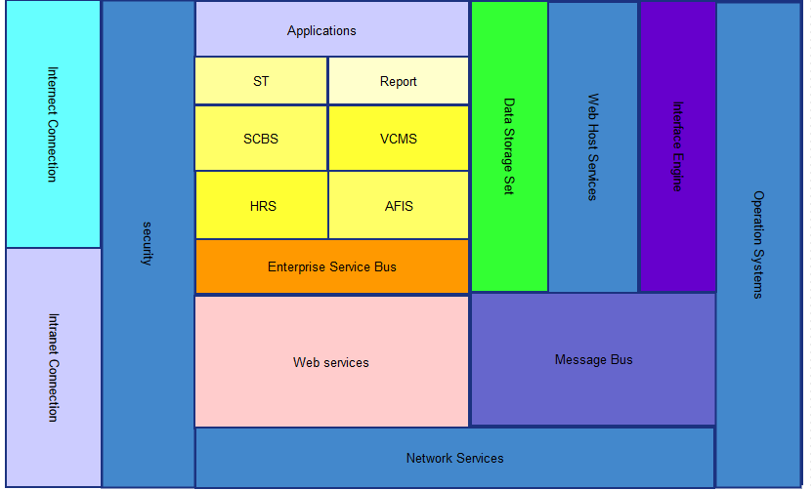

Figure Technical Reference Model

* **Operation Systems** is the basic component for other applications. For security, stability and high performance purpose, and work with Oracle DB and Java language, Linux is the best choice in the market. On the market there are many distributions, and here the choice is RHEL: Red Hat Enterprise Linux, that means it's stable and handles heavy loads well.
  + Basic operation service
  + Datetime synchronization service
  + File storage service
  + Host for other services
* **Network service** provides low lever communcation service between physical servers.It’s running at network application layer and above,provides data presentation , communication and validation using TCP/IP protocol.

To support network service for all servers, following compnents are needed:

* + Network adapter
  + Network router
  + TCP/IP Protocol
  + Other necessary component to support network connection
* **Security** component including necessary hardware components and related software which warpe all important factors,they are
  + Hardware firewal
  + Software firewall
  + Server security components
  + Authorisation,Authentication and Access Control components
  + Log tracking
  + Encryption and Decrpytion components
* **Internet connection and Intranet connection,** by defination, an intranet is a computer network that uses Internet Protocol technology to share information, operational systems, or computing services within an organization. For security reason, internal project can only be accessed by intranet to protect it’s privacy.
* **Message bus ,** is used for interprocess communication. It uses a queue for messaging – the passing of control or of content. Group communication systems provide similar kinds of functionality. This component is using for transfer data between VCMS and SCBS.
* **Web Services,** The W3C defines a Web service as:a software system designed to support interoperable machine-to-machine interaction over a network. It has an interface described in a machine-processable format (specifically WSDL). Other systems interact with the Web service in a manner prescribed by its description using SOAP messages, typically conveyed using HTTP with an XML serialization in conjunction with other Web-related standards.

When any application want to open API to other parties, the request will go through web service components.

* **Interface Engine**, This component is using for receive message and data from web service components and message bus components and delegate to target system with certain format.
* **Enterprise Service Bus**
  + Monitor and control routing of message exchange between services
  + Resolve contention between communicating service components
  + Control deployment and versioning of services
  + Marshal use of redundant services
  + Cater for commodity services, i.e. Message bus, web service and network services
* **Web Host service**
  + Website host service
  + API host service
  + File storage service
* **Data Storage Set**
  + Databases
  + Replication service
  + Disater recovery service
  + Reporting generation service
* **Applications,** 6 applications are involved: Vessel and Container Movement System (VCMS), Sales and Customer Billing System (SCBS), Account and Financial Information System (AFIS), Human Resource System (HRS), Reporting Service and Shipment Tracking Service(ST) Following services are included:
  + Application UI Design Standard (IE,FF and Chrome supported)
  + Application development
  + Application testig
  + Applicaion deployment
  + Configuration Management
  + Integration Services.

## Technical Principles and Best Practices

|  |  |  |
| --- | --- | --- |
| Model Name | Technical Principles | Best Practise |
| Internet/Intranet | The appropriate security measures must be put in place to ensure security and privacy protection. | HTTP,FTP,Email Service |
| Security | The appropriate security measures must be put in place to ensure security and privacy protection | C2 Firewall Service  Norton Security Service |
| Applications(VCMS,ST,SCBS,etc) | Reuse everything that can be reused. Design and produce with reusability in mind. | Oracle-Java programming best practise |
| Data Storage Set | Reuse everything that can be reused. Design and produce with reusability in mind. | Oracle Database group |
| ESB,IE,MessageBus,Web Service | Information from across all the regional units, customers and port operators should be integrated. | Json 1.0  XML  Message Queue |

## Current List of Technology Architecture

|  |  |  |  |  |  |  |  |  |
| --- | --- | --- | --- | --- | --- | --- | --- | --- |
| No. | Technology Category | Technology Standard | Brand, make and model | Applications Supported | Location | Vendor | Quality of Service | Compliance to Product Stds |
| 1. | Customer Billing System(CBS) | Java | Oracle, Version 7 Update 21 | N/A | Unknown | SGLines | Nill | Yes |
| 2. | Sales Order System(SOS) | C++ | Borland | CBS | Local office | SGLines | Nill | Yes |
| 3. | Container Movement System(CMS) | Prediction Engine | Nill | SOS,CBS | High-end WinTel Server | SGLines | Have 10%-15% unscheduled downtime | Yes |
| 4. | Human Resource System(HRS) | Java | Oracle, Version 7 Update 21 | MQ Series  Java API | AS400 Server | SGLines | Nill | Yes |
| 5. | Account and Financial Information System(AFIS) | Java | Oracle, Version 7 Update 21 | MQ Series  Java API | AS400 Server | SGLines | Nill | Yes |
| 6. | Vessel Movement System (VMS) | C++ | Borland | CMS,SOS  CBS | High-end WinTel Server | SGLines | Have 10%-15% unscheduled downtime | Yes |
| 7. | SGLine Website | HTML 4.0 | N/A | N/A | Local ISP | SGLines | Nill | Yes |

## Target List of Technology Architecture

|  |  |  |  |  |  |  |  |  |
| --- | --- | --- | --- | --- | --- | --- | --- | --- |
| No. | Technology Category | Technology Standard | Brand, make and model | Applications Supported | Location | Vendor | Quality of Service | Compliance to Product Stds |
| 1. | Operation System Services | Linux | Redhat Linux | Application Services | Cloud | Redhat | 99.9999%  Available | Yes |
| 2. | Network Services | IEEE802 | Starhub | Application Services | Telecom | Starhub | 7x24 online | Yes |
| 3. | Security | Firewall | C2 Hardware Firewall  Norton Software firewall | Application Services | Cloud | C2, Norton | Enterprise support | Yes |
| 4. | Interface Engine | Java, XML,Json | Oracle Java Version7 ,  XML 1.0 5th Edition,  Json 1.0 | API Service | Server | SGLines | 7x24 Available | Yes |
| 5. | Web Service | XML,SOAP | W3C | API Service | Server | SGLines | 7x24 Available | Yes |
| 6. | Data Storage Set | T-SQL Standard | Oracle 11i | Application Services | Data Center | SGLines | 7x24 Available | Yes |
| 8. | Web Host Service | HTTP,HTTPS | W3C,Apache Web Server | Web applications | Cloud | SGLines | 7x24 Available | Yes |
| 9. | Applications  ST  Report  SCBS  VCMS | Java,MVC,Javascript, HTML5.0, CSS3 | Oracle 11i  W3C | NA | Server | SGLines | 7X24 Available | Yes |

## 

## List of Stakeholders and their Concerns

|  |  |  |
| --- | --- | --- |
| Stakeholder | Concerns | View |
| Customer | Easy to access the web site  Easy to access on-site data  Able to direct RFQ, ordering and calculation shipment time online  Security | Conceptual Data Model |
| IT Staffs | Able to maintain the system easily.  Able to add new futures to current system | Target Technology Architecture |
| Sales Team | One-site access. Don’t want to access different system to complete one task. | Target Technology Architecture |
| Order processing  Administrator | More user-friendly and easy to use system | Target Technology Architecture |
| Management team | Real time report. | Target Technology Architecture |
| Port operator | Able to determine optimal container movement and placement within a vessel by web services. | Target Technology Architecture |

## Current and Target Technology Architecture

Current technology architecture provides the hardware level diagram.

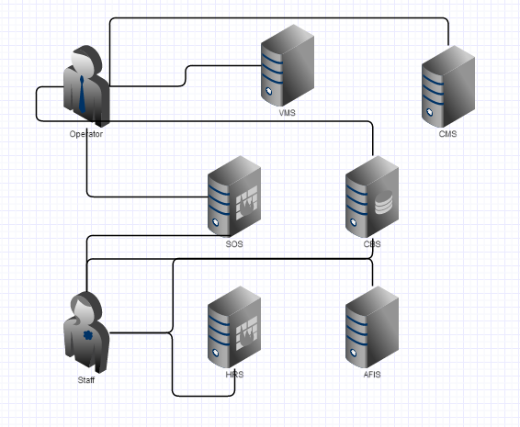

Figure 6 Current Technology Architecture

The target technology architecture gives an overview of the proposed system level design that the EA should be consolidated to.

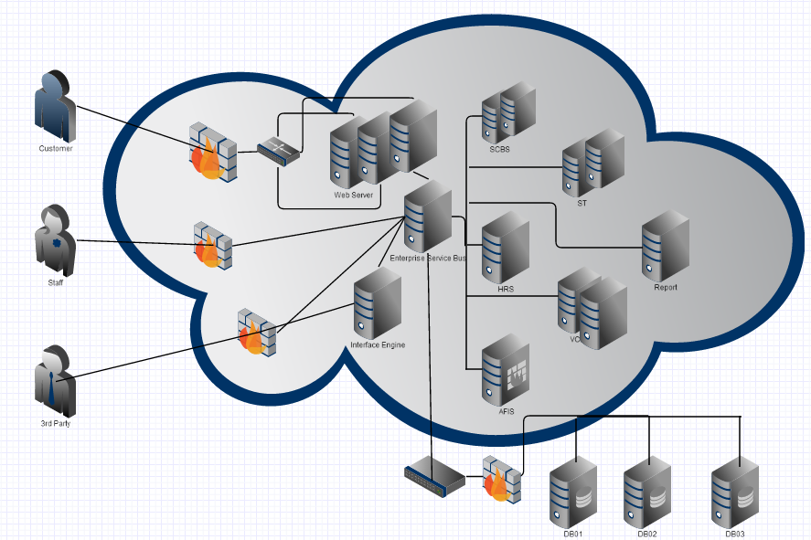

Figure 7 Target Technology Architecture

## List of Technology Architecture Gaps

|  |  |  |  |  |  |
| --- | --- | --- | --- | --- | --- |
| No. | Description | Current State | Future State | Importance/Benefit | Address by Architecture |
| 1. | System security | No firewall found | Everything will hide under firewalls | Increase security | Technical |
| 2. | Network latency | Not mention LB not | Will include in all web servers | Increase performance and usability | Technical |
| 3. | VMS and CMS tend to have unscheduled downtime | 10%-15% unscheduled downtime always happen | System availability should reach 99.97% | Unscheduled downtime will reduce usability | Technical |
| 4. | VMS and CMS were developed based on old technology | Nobody can maintain that system | Will use Java to develop and follow the java standard, easy to maintain | Easy to maintain and enhance the system | Technical |

# Opportunities and Solutions

## Initiatives Description, Traceability, Priority

|  |  |  |
| --- | --- | --- |
| **Initiatives** | **Traceability to Gap** | **Priority** |
| Re-engineer existing business processes | B1, B2, B5 | High |
| Establish more customer focused services to improve customer satisfaction. | B3, A16 | High |
| Re-structure application systems | B4, I6, I10, A11, A12, A18 | High |
| Provide interface for internal/external system to integrate. | I9, A14, A15 | Medium |
| Improve performance and enhance security in systems. | A13, A17 | High |
| Standardize data storage for system integration. | I7, I8 | High |
| Adapt new technology to improve system stability and ease for maintenance. | T19, T20 | Medium |
| Produce management report for marketing analysis and strategy change. | B4 | Medium |
| Procure new hardware. | T21, T22 | Low |

## Checklist of Gaps and Addressed Gaps

|  |  |  |  |  |
| --- | --- | --- | --- | --- |
| No. | Architecture | Gap | Potential Solution | Dependencies |
|  | Business | Too much manual intervention required | * Re-engineer existing business processes to reduce manual effort and improve business efficiency |  |
|  | Business | Integrate e-Business with partner and customer’s IT system | * Revamp and consolidate SOS and CBS * Revamp and consolidate VMS and CMS * Integrate internal systems to improve business process efficiency | Drives Application 11, 12 and 18 |
|  | Business | Focus on customer service is not enough | * Provide customer registration. * Provide online order submission and order status tracking * Provide online shipment tracking * Accelerate process for repeat orders | Drives Application 16 and 18 |
|  | Business | Inaccuracy in sales report and transaction data. | * To provide management report from consolidated system for better marketing analysis and decision |  |
|  | Business | Lack of management and monitoring in cooperation with local operators of tow-heads and port operators | * Enhance existing systems to manage tow-heads operators and port operators * Keep track of co-operators to help to make engagement and manage cost |  |
|  | Information | Lack of knowledge in SOS system | * Study the implementation of SOS * Gather requirement of SOS before revamping the system |  |
|  | Information | Legacy data from SOS system | * Proper data migration to move the data to new system |  |
|  | Information | Data are stored with different standard in different systems | * Standardize the data storage. To develop a common data dictionary as guideline | Prerequisite for all applications |
|  | Information | Lack of consistency in container and vessel optimization decision | * Centralize and standardize the optimization algorithm for organizing container |  |
|  | Information | Tow-head operator information is not managed | * To capture tow-head operator details information in system |  |
|  | Application | Develop centralized SCBS system by consolidating and revamping SOS and CBS system | * Develop the required system * Implement system failover to ensure system high availability | Dependent on Information 6, 7 |
|  | Application | Develop centralized VCMS system by consolidating and revamping VMS and CMS system | * To develop the required system * To include tow-head operator management functions * To implement system failover to reduce the unscheduled downtime |  |
|  | Application | Container Movement prediction engine requires high computational load and it would affect the performance of VCMS | * Separate the Container Movement prediction engine * Deploy the engine in another distributed server * To provide the remote method invocation to VCMS |  |
|  | Application | Integration to SCBS for sophisticated customer’s procurement system | * Develop a set of Web Services in SCBS for integration |  |
|  | Application | Integration to VCMS for Port Operators and internal applications | * Develop a set of Web Service in VCMS for Port Operators to integrate * Develop another set of Web Service in VCMS for internal system to integrate |  |
|  | Application | Online RFQ and order submission is not supported | * Integrate SGLines Web site with SCBS to allow customer registration * Integrate SGLines Web site with SCBS to allow customer to submit RFQ and order online from a new Web storefront * Customize the Web contents for different customer type and country * Support different types of browsers |  |
|  | Application | Generating management report would impact VCMS performance | * Replicate data for VCMS system using DB feature and set the replicated data to be read only * Access replicated DB to generate management report |  |
|  | Application | Order process is not fully automated | * Allow customer to continue to place order after RFQ with the details stated in RFQ * Integrated SCBS and VCMS using Web Services provided for internal use to automate RFQ and order process |  |
|  | Technology | VMS and CMS were developed based on old technology | * Adapt new technology when developing the consolidated VCMS system |  |
|  | Technology | VMS and CMS tend to have unscheduled downtime | * Improve application architecture when developing the VCMS system * Improve code quality for VCMS development * Emphasize QA and plan sufficient review and testing to ensure the quality for the mission critical system * To implement system failover to reduce the unscheduled downtime |  |
|  | Technology | Network latency | * Increase network bandwidth * Separate Web Servers for transaction from staff and customer * Install load balancer on top of Web Servers |  |
|  | Technology | System security | * Install and configure firewall for systems * Separate Web Servers for transaction from staff and customer * Require staff to use signed Java applets for secured login and encrypted client side processing |  |

# Migration and Implementation Road Map

## Project Identification, Quantification and Differentiation

SGLines target architecture will inclusive of introducing new system implementation at the same time phasing out un-used or unsupported legacy system. Below is the breakdown of the projects